NEWSLETTER

No. 05, Term 01, Week 09

Monday 26 March 2018

Greetings, Kia ora, Talofa lava, Kia orana, Malo e lelei, Fakalofa Lahi Atu, Namaste, An Young Haseyo, Konichiwha, Bula Vinaka, Sawadee, Dobra Dan, Ni Hao, As-salamu alaykum, Hola

From the Principal – Mrs. Watt

ASB Banking
We can now offer school banking. Banking day is on Friday. Forms are located on the Kashin the Elephant bank deposit box in our reception area. When children sign up to open an ASB account, they will be sent a Kashin deposit box and calculator in a yellow bag - all to keep. If you’d like to register your child for free, for this, please see our friendly office staff.

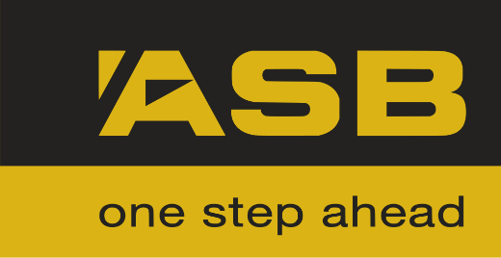

Panmure District School Baking Programme
Baking has been cancelled for two weeks and will resume on Wednesday 11th April.

SPORTS NEWS

Kung Fu Classes
The Kung Fu School has a new club in Mt Wellington operating now! Classes are held in our school hall and are for Students aged 7 and up.
Classes are currently Wednesdays at 6:15 pm to 7:15 pm. Parents are welcome to attend and the first class is free.
Benefits of training in Shaolin Kung Fu include increased: fitness, self-defence, confidence, discipline focus and many more.
Visit our website www.shaolinkungfu.co.nz

Winning House
Congratulations Totara House - the winning house for the week.
TOTARA

Reminder
This Friday the school is closed due to Easter Holiday. The school reopens on Wednesday 04 April.
Term 1 ends on Friday 13 April
Term 2 starts on Monday 30 April.

Youth Town Holiday Programme Available

- Holiday Programme Options (for Primary and Intermediate School students – all ages years 0-8!)
- FREE Holiday Programme West and South Akd only (for Intermediate and Secondary School students – all ages 11-17 welcome!)

And one of these links relate to your local Youth town’s website page for more details (plus on-line booking)
http://www.youthtown.org.nz/locations/auckland/north-shore
http://www.youthtown.org.nz/locations/auckland/central-auckland
http://www.youthtown.org.nz/locations/auckland/west-auckland
http://www.youthtown.org.nz/locations/auckland/east-auckland
http://www.youthtown.org.nz/locations/auckland/south-auckland

UPCOMING EVENTS

Friday 6th April - PDS Open Day. Come and see learning in action! We’d like to extend an invitation to friends and whanau to come in and have a look at PDS learning in action. Children would love to share their learning with you.

Merit Awards
Room 1 -
Whole Class for their excellent behaviour, best learning, great manners, time and self-management.
Ivanya Halolava for her best learning, great writing and for her excellent behaviour.

Room 2 –
Jayla Aselemo for being a wonderful leader and a super role model to her peers.
Ezekiel Marsh for independently writing and working hard on letter formation.

Room 3 –
Beckham Sok for his efforts to improve his persuasive writing body.
Sione Ofakineiafu for his excellent basic facts recall for multiplications.
Room 05 –
Benja Wanmontree for participating and contributing actively during group discussions.
Mariesall Schwenke for doing all her homework regularly.

Room 07 –
Ana Kaufusi for mentally performing calculations involving addition and subtraction of 2 and 3 digit numbers.
Krrish Narayan for listening to and responding to others in group discussions.

Duffy Awards
Hazel Godoy for always displaying positive attitudes in our school values.

Fatima Kaufusi for being a very responsible lunch monitor.

Tamatea Turua for his efforts to remain focused for reading.

Fakatu’a Kaufusi for contributing ideas to co-construct success criteria during reading sessions.

Lorraine Toki for asking questions to clarify her doubts when reading.

CONGRATULATIONS

Environmental Award:
Room 7 – for having a tidy and presentable classroom area.
Keep up the good work

